**CHILD PROTECTION INFORMATION SHARING: DISCUSSION PAPER**

**Background**

Child Protection Information Sharing (CP-IS) was introduced through NHS digital in March 2017.

The cohort of children for CPIS is children who are currently the subject of a child protection plan or who are in the care of the local authority or have been in either of these situations in the previous 12 months.

The concept was that health professionals working in unscheduled health settings such as 111 and A & E departments could, where they had cause for concern, identify via the NHS spine whether a child or young person is in the CPIS cohort which in turn may influence their decision making.

When a record is viewed, a notification is created via the NHS spine and delivered to the Local Authorities case management system, in our case CareDirector.

**Implementation in Staffordshire**

In Staffordshire, to support this process the following procedure was introduced within Care Director

* Cases where a child has a current social worker

When a notification has been received from the NHS spine i.e the record has been accessed, three alerts in the form of a Care Director activity are created. One is sent to the social worker, one is sent to their team manager, and one is sent to the team inbox. The social worker is meant to read the activity, complete that activity, open a new activity to record the action taken in response to the alert and then complete that activity. The copy sent to the team manager and the inbox were a ‘belt and braces’ approach.

* Closed cases

When a notification is received from the spine then two alerts are created and sent to First Response. First Response are meant to check how many previous alerts have been received on that child or young person and if three or more alerts have been received in the previous six months, then they are meant to follow up and investigate that final alert.

**Practice Issues**

What hadn’t been appreciated when our internal process was designed was that multiple alerts are being created and sent via the spine on single incidents. For instance, a parent rings 111, NHS Direct automatically make the enquiry and a notification is sent to CareDirector which then triggers a number of activities. If the ambulance service are required, they appear to be making a second enquiry via the spine which generates one alert. The ambulance crew on route also make an investigation this generates a second notification and subsequent activities. The child or young person is taken to A&E, they too make an enquiry so we have a third notification and automated activities. If the child is admitted to a ward, again they make an enquire giving us a fourth notification and fourth set of activities.

What was originally envisaged was the enquiry would only be made if the health professional had a specific concern. This does not appear to be what is happening in practice What appears to be happening is that making an enquiry is now a routine process for health professionals.

The consequences is we are now being inundated with notifications and automated activities.

Number of CP-IS notifications generated since go live is 5992

Those notifications have generated 14237 activities

On 335 occasions an activity recording any follow up conversations have been created.

No referrals been raised as a result of follow up enquires made at First Response.

The content of the information received by the practitioner can be confusing and difficult to understand. Below is a typical notification

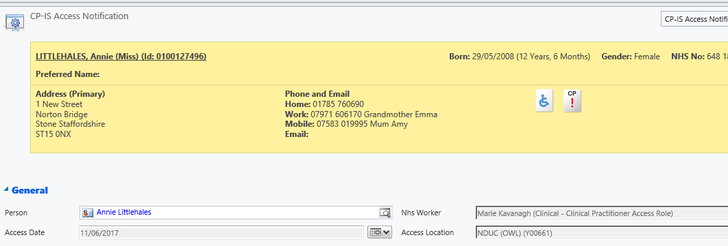

Cannot easily identify where the enquiry originated, access location code is presented which you have to Google to find out what it relates to and then you have to try and contact that individual within the establishment who may or may not be on duty.

There is further concern that this is going to be extended to GP surgeries and potentially increasing the cohort to include CIN cases.

Jan Cartman-Frost and Amy Grice have been nominated to attend the National Local Authority User Group and the views from this group are broadly similar to those expressed in this paper.

**Decisions**

1. Agreed SCC internal process adopted to record receipt of CP-IS alerts and recording of subsequent actions is over bureaucratic and practitioners need to be using the CP-IS Notification module as part of daily practice. The alerts to the practitioners in the form of task note activities is to cease.

**Actions:**

* Families First CareDirector Support Team to submit Change Request so that the CP-IS notification Module is displayed on their landing page.
* Becky Reynolds to provide communication and practice guide to remind/reinforce the review of the CP-IS information as part of best practice. Social worker makes enquiries if they feel it is relevant and records action taken as a case note
* Amy Grice to raise SCC concerns abut the process by providing case studies to NHS digital.

1. Where notifications are received on closed cases, no alerts are generated to First Response. It is the responsibility of the health professional/agency viewing the CP-IS record to make a referral into First Response/EDS if the presenting issue meets the threshold.

Actions:

* Families First CareDirector Support Team to arrange for current workflow to be disabled in Version 6.
* Clive Cartman-Frost to advise First Response workers to delete current alerts being generated in Version 5
* Amy Grice to update Health partners via the Staffordshire Safeguarding Children Board of SCC practice and reinforce referral process/pathways.

.