Stoke-on-Trent and Staffordshire
Child Exploitation Strategy
2019-2022

- Foreword

As current Chair of Stoke-on-Trent and Staffordshire Safeguarding Children Board (SSSCB) I am pleased to present our Child Exploitation Strategy.

Protecting children from child exploitation has been, and remains, a priority for our Safeguarding Children Board. This strategy builds on the work already in place across Stoke-on-Trent and Staffordshire as risks to children of exploitation have been recognised for several years.

This document emphasises the importance of a strong partnership across all agencies responsible for safeguarding children. Organisations such as Staffordshire Police, local NHS services and the two local authorities cannot work in isolation when seeking to combat child exploitation and protect children and young people in Stoke-on-Trent and Staffordshire. It is only through working together that we will be successful in our work in this complex area.

We know that child exploitation can have a devastating impact on children and their families. We also know that to prevent it we need a workforce that is well trained, skilled and confident. Stoke-on-Trent and Staffordshire Safeguarding Children Board will seek assurances that professionals from all agencies are equipped to undertake this work and recognise, for example, the vulnerability of children who go missing from home, school or care settings. We will scrutinise and seek assurances of the actions all agencies have agreed to undertake to support the strategy.

Finally, and most importantly, we will listen to children and young people in Stoke-on-Trent and Staffordshire to understand how we can support them, what services meet their needs and how we can prevent child exploitation in our communities.

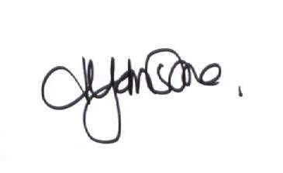
Heather Johnstone

- Introduction
This document outlines Stoke-on-Trent and Staffordshire Safeguarding Children Board strategy for preventing, identifying and tackling child exploitation. It has been developed using the knowledge gained from local needs analysis in respect of child exploitation across both areas and has drawn upon national policy and guidance about effective practice.

Our approach to child exploitation encompasses child sexual exploitation, child criminal exploitation and, where there are links to child exploitation, gangs, county lines, knife crime, radicalisation, youth violence, modern slavery and child trafficking. The strategy recognises and addresses the risks and vulnerabilities faced by children who go missing and those who are victims or witnesses of domestic abuse.

Local policies and procedures are in place for domestic abuse, radicalisation, modern slavery and human trafficking. These can be found on the Stoke-on-Trent & Staffordshire Safeguarding Children Board website.

Our strategy uses the following definitions:

Child Sexual Exploitation
Child sexual exploitation is a form of child sexual abuse. It occurs where an individual or group takes advantage of an imbalance of power to coerce, manipulate or deceive a child or young person under the age of 18 into sexual activity (a) in exchange for something the victim needs or wants, and/or (b) for the financial advantage or increased status of the perpetrator or facilitator. The victim may have been sexually exploited even if the sexual activity appears consensual. Child sexual exploitation does not always involve physical contact; it can also occur through the use of technology. (Dept. for Ed: Definition and a guide for practitioners, local leaders and decision makers working to protect children from child sexual exploitation, Feb 2017)

Child Criminal Exploitation
Child Criminal Exploitation (CCE) occurs where an individual or group takes advantage of an imbalance of power to coerce, control, manipulate or deceive a child or young person under the age of 18 into any criminal activity (a) in exchange for something the victim needs or wants, and/or (b) for the financial or other advantage of the perpetrator or facilitator and/or (c) through violence or the threat of violence. The victim may have been criminally exploited even if the activity appears consensual. CCE does not always involve physical contact; it can also occur through the use of technology. (Home Office: Serious Violence Strategy, April 2018)

Gangs
A relatively durable, predominantly street-based group of young people who:

- See themselves (and are seen by others) as a discernible group, and
- Engage in a range of criminal activity and violence

They may also have any or all of the following factors:

- Identify with or lay claim over territory
- Have some form of identifying structural feature
- Are in conflict with other, similar, gangs

(Centre for Social Justice, Dying to Belong, 2009)

County Lines
County lines is a term used to describe gangs and organised criminal networks involved in exporting illegal drugs into one or more importing areas within the UK, using dedicated mobile phone lines or other form of “deal line”. They are likely to exploit children and vulnerable adults to move and store the drugs and money and they will often use coercion, intimidation, violence (including sexual violence) and weapons. (Home Office: Criminal Exploitation of children and vulnerable adults: County Lines guidance, Sept 2018)

Radicalisation
Radicalisation refers to the process by which a person comes to support terrorism and
extremist ideologies associated with terrorist groups. (HM Govt: Prevent Duty for England and Wales, July 2015)

Both Staffordshire and Stoke-on-Trent have established statutory Channel Panels, which allow joint working between local authorities, Staffordshire Police and their partners to offer help and guidance to people who may be at risk of becoming involved in extremism. We will ensure that information is shared, as appropriate, to facilitate joined-up working in relation to child exploitation where radicalisation is identified as a risk-factor.

Modern Slavery
'Modern slavery' is a term which encapsulates slavery, servitude, forced or compulsory labour and human trafficking. (Modern Slavery Act, 2015)

Child Trafficking
Child trafficking is defined as the “recruitment, transportation, transfer, harbouring or receipt” of a child for the purpose of exploitation. (United Nations: Palermo Protocol to the United Nations Convention against Transnational Organised Crime, 2000)

- National context
Tackling child exploitation is a complex task. Children do not always recognise the coercive nature of the relationship and do not always see themselves as at risk of exploitation. There is growing national recognition of the similarities between different forms of exploitation and the criminal and sexual exploitation of children may overlap. Victims of child exploitation may, at any one time, be subject to both.

Perpetrators of Child Sexual Exploitation (CSE) and Child Criminal Exploitation (CCE) can share patterns of behaviour in respect of coercion, violence, intimidation, and the power imbalance inherent in them and many other offences. However, circumstances in which the exploitation occurs can demand different approaches. It should also be recognised that children may be both victims and perpetrators of exploitation.

Although there is some evidence across the country of areas joining together these agendas, the umbrella term of Child Exploitation is currently seldom used. The preference seems to be to look at both CSE and CCE as separate issues albeit increasingly recognising the links between the two. In Staffordshire, adopting the umbrella term of Child Exploitation has provided the opportunity to bring together these complex work areas.

It is increasingly recognised across the country that all forms of exploitation take place irrespective of social class, race and ethnicity, gender, urban and rural areas. However, it is also widely recognised that perpetrators are more likely to target children who are more vulnerable due to social, economic or emotional factors.

As such there has been growing evidence and research to suggest that a contextual safeguarding approach is often required in this work. Initially developed by Bedfordshire University six years ago, contextual safeguarding is an approach to safeguarding children which responds to their experiences outside of the home. As part of the contextual safeguarding scale up project Bedfordshire University have selected several Local Authorities to test the approach further. It is important that Staffordshire continue to learn from this pilot and change practice in line with the emerging evidence base, as necessary and ensure that this approach is embedded in practice across Staffordshire.

More recently, for the first time, Working Together 2018 recognises contextualised safeguarding and children with complex safeguarding needs where the harm/abuse occurs outside the home and is not related to the care given to the children by their parents or family. It provides useful clarity regarding statutory intervention for children where abuse takes place outside the family home. The general rhetoric around this guidance remains the same but equally important, everyone who comes into contact with children has a role to play and a child centred approach is fundamental to safeguarding and promoting the welfare of every child.

Other guidance documents on this work area include the Serious Violence Strategy 2018 which sets out four key themes; tackling county lines and misuse of drugs, early intervention and prevention, supporting communities and partnerships and an effective law enforcement and criminal justice response. There are clear parallels between all of these and Child Exploitation. The introduction of the Early Intervention Youth Fund and the new National County Lines Co-ordination Centre as will have a clear impact on Child Exploitation.

Keeping Kids Safe, the report by the Children’s Commissioner published in 2019, undertook research in an attempt to describe what it’s like to be a child gang member. It estimates how many children are in gangs including looking at the risk factors which make it more likely for a child to be groomed for gang membership and questions whether those responsible for safeguarding children are responding adequately to the rise in gang violence and how children can better be kept safe. Recommendations include taking a life-course approach, making every contact with children and families count, local-level identification and co-ordination and ensuring a national level response.

Serious case reviews and learning reviews from other areas in the country also provide us with many recommendations for future practice. The Newham Serious Case Review into the death of Corey Junior Davies revealed that despite hundreds of professional hours provided by a multitude of people, little changed for Corey and risk was not effectively managed as evidenced by an upwards trajectory of risk and offending. Recommendations included undertaking a full review of multi-agency risk and vulnerability panels, to strategically and operationally realign work with young people at risk of CCE with CSE and to consider the creation of a contextual safeguarding hub, ensuring that there are appropriate policies, procedures and pathways in place for children at risk of gang affiliation and criminal exploitation, recognising there is often an overlap and ensuring that there is access to independent return interviews for young people returning from missing episodes linked to criminal exploitation.

Similarly, the Vulnerable Adolescents Thematic Review (2019) conducted by Croydon Safeguarding Children Board Croydon review, following the tragic death of three Croydon teenage boys, offers a number of recommendations for future service delivery.

These include the importance of prevention and early help, greater recognition of, and response to, children’s emotional health and wellbeing, an integrated whole systems approach across agencies, communities and families and ensuring that issues of gender, ethnicity and deprivation are at the forefront of service delivery.

Practical solutions to support frontline staff to tackle child exploitation have also been made recently available. The Home Office Child Exploitation Toolkit (2019) provides a range of multi-agency professionals with a toolkit to safeguard children from sexual and criminal exploitation. It also sets out how existing legislative powers, such as orders and injunctions, are an essential part of the safeguarding process for all professionals.

Whilst the above is not intended to be a comprehensive literature review it provides us with some important considerations and key learning which needs to be considered in the development of this Strategy, associated delivery plans and operational practice in relation to Child Exploitation in Staffordshire.

Staffordshire will continue to use all the national research, policy and guidance to help us implement our strategy locally. Undoubtedly the information available for this work area will continue to increase so it is important that we are flexible to change in line with best practice.

- Local context
Stoke-on-Trent and Staffordshire have well developed procedures to identify and support children who are at risk of Child Sexual Exploitation. This area of work has been a priority of both Local Childrens Safeguarding Boards since 2015. The Child Sexual Exploitation Strategy 2016 – 2020 asserts;

“Our intention is for every child, parent, carer, community member and individual who make up our multi-agency workforce to understand what child sexual exploitation is and know how they can play a part in preventing it. This will help children and young people to understand the potential dangers of exploitation and abuse, make safer choices and build their resilience.”

Through the commitment of all agencies and the two Local Childrens Safeguarding Boards both Local Authorities have made significant advances in this area and now have a well co-ordinated response.

In 2014 Stoke-on-Trent took part in the Ending Gang and Youth Violence Peer Support Programme. This review highlighted a number of areas of good practice along with recommendations for further developments. Since 2014 the Partnership has moved from a reactive to a proactive approach to tackling youth violence. The governance of the Youth Violence and Vulnerability agenda has strengthened, and the Youth Violence and Vulnerability Working Group has been established which oversees the work of all partners to reduce the occurrence and impact of serious youth violence and criminal child exploitation.

The partnership has benefitted from taking on board national learning including the move towards understanding that many young people are at risk of criminal child exploitation and county lines. There is now greater understanding by professionals around the links between child criminal exploitation, carrying of weapons, drug supply and child sexual exploitation.
However, it has become increasingly evident, both national and locally, that a joined-up approach to both Child Sexual Exploitation and Child Criminal Exploitation may be beneficial for children, parents/ carers and their communities. Therefore, a Stoke-on-Trent and Staffordshire task group was established to examine the data surrounding those children who may be vulnerable to child exploitation and to use this, along with other local and national learning, to develop a co-ordinated strategic approach.

4.1 Data
We have undertaken analysis of local data to inform the development of this strategy. We cross referenced a number of datasets indicative of vulnerability to see how many children were present on multiple occasions. A case file review was undertaken of those children who were identified within 5 or more populations, to validate the data and to test the validity of our findings.

4.1.1 Staffordshire Findings
Just over one thousand children were present in two or more populations. Of these 738 were present in 2 populations, 179 in 3 populations, 67 in four populations, and 30 in 5 or 6 populations.

Children who were identified in the permanent exclusions cohort and children who were known to CSE panels or to Building Resilient Families and Communities (Crime & ASB) were most likely to appear in 3 or more populations.

There was no clear pattern to which 3 populations children appeared in most often.
Of the one thousand children appearing 2 or more populations, 388 had recent early help involvement and 233 had a recent history of 20 or more unauthorised school absences. 55 of the children/young people had recently been looked after and 47 had recently been subject of a child protection plan.

Fig. 1: Staffordshire Data
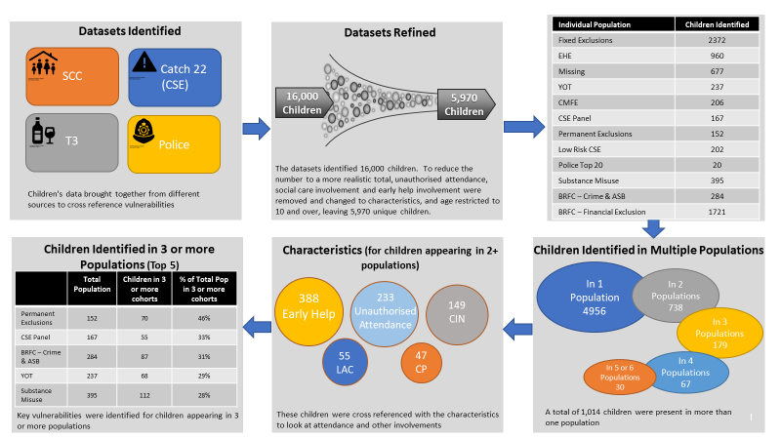

4.1.2 Stoke-on-Trent Findings
472 children were present in two or more populations. Of these 345 were present in 2 populations, 90 in 3 populations, 28 in four populations, and 9 in 5 or more populations.

Of the 472 children appearing 2 or more populations, 98 had recent early help involvement and 223 had a recent history of persistent absence where attendance was below 90%. 55 of the children/young people had recently been looked after either by Stoke-on-Trent or by another local authority but placed in Stoke-on-Trent and 30 had recently been subject of a child protection plan.

Fig. 2: Stoke-on-Trent Data

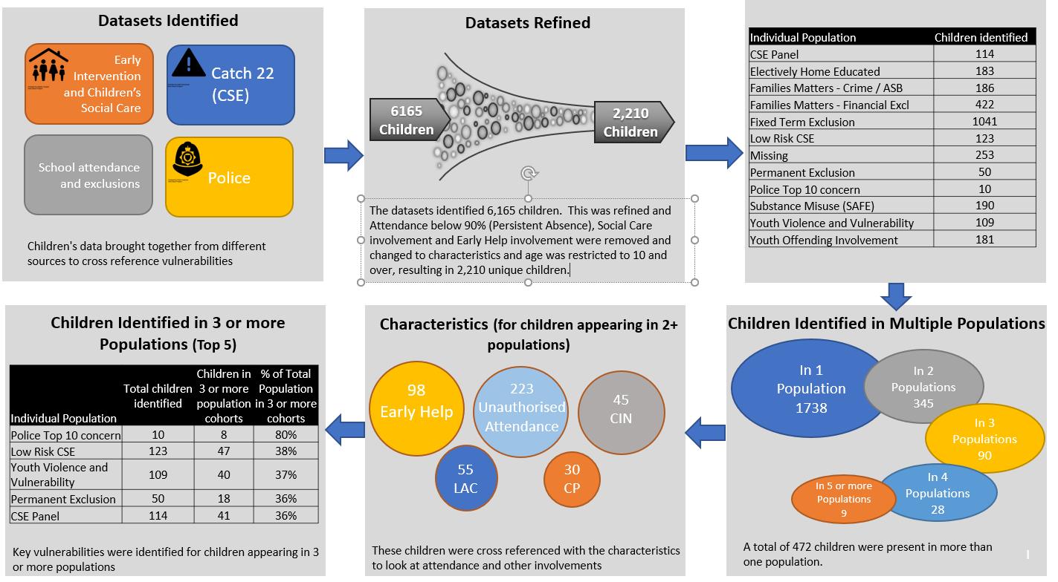

4.2 Consultation
This strategy has taken into account the findings of local consultation.

Staffordshire Youth Commission is based on a youth driven consultation model which allows young people to put forward solutions to key problems that
“There are warning signals that people need to act on.” *
they identify within their communities. The key element of the Youth Commission role is to gather
the views of young people through peer-to-peer engagement.

In 2018, the Youth Commission undertook consultation with young people in relation to five priority issues that they identified as affecting their peer groups and communities. These priorities included knife and gang crime, abuse and child sexual exploitation and community breakdown.
“You see what everyone else has and you want that for yourself.” *
The Youth Commission gathered over 2,400 constructive responses from young people across Staffordshire in relation to their five priorities. They asked a range of questions including asking respondents to consider how young people can be protected from engaging in criminal behaviours, what are the barriers to victims and perpetrators of CSE coming forward and seeking help and why young people may join a gang or carry knives.

Findings included that young people may not know who to speak to if they need support, for example if they need help to leave a gang and there is a lack of awareness of support networks. In relation to CSE and abuse, responses suggested that young people may not report an incident as a result of shame or fear and the associated stigma.
“Kids need to see the consequences, they need to speak to people who have lived it.” *

Staffordshire Consortium of Voluntary Youth Services recently undertook research, using both quantitative and qualitative research approaches, including surveys, focus groups and one-to-one interviews with young people. Their findings highlight the need locally to include and involve young people, invest in extracurricular activities and work with families and communities to embed solutions. They also found that most young people want to break free from negative cycles, but often lack the knowledge or support to do so.
“When I was living in it, I couldn’t see I was being exploited.” *

* Comments from young people at a local HMYOI, regarding their own experiences of child criminal exploitation.

- Vision for Safeguarding in Stoke-on-Trent and Staffordshire
Safeguarding children especially the most vulnerable is a core duty and responsibility for all agencies in Stoke-on-Trent and Staffordshire. Protecting, safeguarding and ensuring the wellbeing of children are complex tasks that can only be successfully achieved by agencies working together in a coherent, honest and effective manner. The vision of the Stoke-on-Trent and Staffordshire Safeguarding Children Board is for children to be well educated, healthy and safe, cared for by resilient families and strong communities.

In relation to child exploitation, our vision is to work in partnership to prevent child exploitation from happening and, where it does happen, to ensure that victims are supported and perpetrators are held to account for their actions and face the full extent of the law.

- Principles
The ‘Final Report of The Office of the Children’s Commissioner’s Inquiry into Child Sexual Exploitation in Gangs and Groups (CSEGG)’ (November, 2013) outlines the ‘See Me, Hear Me Framework’ for action. The report sets out the functions, processes, proposed structure and underpinning principles that need to be in place to help ensure that children and young people are seen, heard and helped:

- Seen: in the context of their lives at home, friendship circles, health, education and public spaces (including social media).

- Heard: by professionals taking time to hear what children and young people are saying and put themselves in their shoes and think about what their life might truly be like.

- Helped: by professionals remaining curious and by implementing effective and imaginative solutions that help children and young people and make them safer.

The overarching aim of the ‘See Me, Hear Me’ framework is that child sexual exploitation is responded to as a child protection and safeguarding issue in accordance with the supplementary guidance to Working Together ‘Safeguarding Children and young people from Sexual Exploitation’ (DCSF, 2009), ‘Working to Safeguard Children’ (HM Government, 2015) and key learning from national child sexual exploitation enquiries.

We have recognised that these principles are also relevant for wider child exploitation and we have adopted the following ‘See Me, Hear Me Framework’ principles:

1. The child’s best interests must be the top priority
The best interests of children and young people and their rights to protection must drive all decision making. The paramountcy principle as outlined in the Children Act 1989 must be adhered to where applicable. All exploited children and young people should be treated as victims of abuse, and be seen as children first, not as offenders. Children and young people being abused or at risk of being abused need to be seen (in the context of their lives at home and outside of their home), heard (we need to take the time to listen to what children and young people are saying) and helped (by professionals remaining professionally curious and by developing imaginative solutions that help children and young people).

2. Participation of children and young people
We need to learn from children’s experiences and capture their voice in the development, implementation and review of the effectiveness of local services.
This participation should include working with parents, carers and communities to help them to keep their children and young people safe. Service providers also need to involve children and young people when decisions are being made about their care, protection and on-going support and kept informed on any issues that affect them throughout.

3. Enduring relationships and support
Support must be tailored to meet the needs of the child, according to their age, identity, ethnicity, belief, sexual orientation, disability, language, and stage of development. Children and young people tell us that having a consistent support worker throughout the whole period of their protection and on-going care is crucial to their recovery.

4. Comprehensive problem-profiling
A joint Strategic Needs Analysis should be compiled with the oversight of the LSCB and shared with key partners to inform the development of evidence based multi-agency strategy and action plans, the commissioning of services and the delivery of training and awareness-raising activity to support local practitioners. The strategic profiling of risk and vulnerability, which includes data from a wide range of organisations, should inform the prioritisation of operational activity.

5. Effective information-sharing within and between agencies
Each area should have a cross sector information-sharing protocol. All relevant agencies and services should be signatories and it should clearly state what information should be shared, by whom and the process for doing this. There should be effective communication, information and intelligence sharing within and between agencies which should underpinned by one locally agreed risk tool. There should also be a range of appropriate interventions and support available to those children and young people who need it.

6. Supervision, support and training of staff
Services should invest in the development and support of staff including providing regular supervision and the opportunities for them to reflect on practice. Those practitioners who offer direct support to exploited children and young people may require further specialist training and need regular opportunities to reflect on their practice with a suitably skilled supervisor. This includes the importance of staff knowing about their role in early help and intervention.

7. Evaluation and review
Evaluations and regular reviews of the effectiveness of the child exploitation strategy and the supporting action plan is necessary to ensure services and interventions are achieving their intended outcomes and meeting the needs of children and young people.

Children who are at risk of or are known to have been exploited may be in need of services under the Children Act 1989 and 2004 and are also children in need of protection. Formal child protection procedures should always be followed where any child is at suspected or known to be at risk of significant harm.

- Purpose
The Stoke-on-Trent and Staffordshire Safeguarding Children Board have resolved to develop and coordinate a cross agency approach to increase effectiveness in tackling child exploitation in respect of four key elements.

PREPARE - strong leadership, effective systems and working with partners
It is widely acknowledged and agreed that only a clearly defined child focused, proactive and co-ordinated, multi-agency approach will be effective in preventing and disrupting child exploitation and bringing perpetrators to justice. Safeguarding partners have demonstrated a strong commitment by signing up to working together to meet the strategic aims and principles set out within this strategy.

PREVENTION - raising awareness of child exploitation amongst young people, parents, carers, the wider community and potential perpetrators
Those who work in the prevention of child exploitation know that the problem continues at an alarming rate and that much work remains to be done to prevent abuse before it happens. As safeguarding partners we know that work on prevention can be effective. Preventative work may include education, raising awareness and understanding and upskilling communities.

A critical protective factor for children and families is that key groups of professionals and community organisations have good understanding and awareness of what child exploitation is and how to spot the signs. One of the key aims of this strategy is to keep prevention of child exploitation in the forefront of people’s thoughts, agendas, and policy discussions in such a way that we help to ensure that all children grow up safe and free from all forms of exploitation. The patterns and prevalence of child exploitation should always be understood so that prevention strategies can be adjusted to meet specific needs.

PROTECTION - safeguarding children and young people and supporting professionals
Children and young people who are victims of child exploitation are often distrustful of adults and may have had negative experiences of statutory services. Whilst there may be situations which require emergency interventions to protect children and young people, the best approach is to work collaboratively with the child or young person and their family.

Taking the right approach to engaging vulnerable children and young people is crucial if we are to stand any chance of supporting them to break free from abuse and exploitation. We want to improve victim’s experiences of being supported, ensuring that they are listened to, respected and given choices about how they are helped. We will work with our commissioned services to ensure that they reflect the needs of our communities and work with our health colleagues around the development of longer-term support for victims.

PURSUE - disrupting, arresting and prosecuting offenders wherever possible and appropriate
Child exploitation has a devastating impact, not only on the child victim but on the whole family. Parents and carers will often want the perpetrators arrested and prosecuted. We are committed to ensuring that we do all we can to disrupt perpetrators who are exploiting children and young people as it is vitally important that all efforts are taken to bring perpetrators to justice.

- Outcomes
We aim to achieve three overarching strategic outcomes:

- Children and young people are not victims of Child Exploitation
- Children and young people are protected from Child Exploitation by parents / carers, communities, professionals and businesses
- Children, young people and adults are not perpetrators and / or groomed to facilitate Child Exploitation

The strategic objectives will be supported by operational outcomes.

- Monitoring Performance
As outlined above, we have agreed three high-level outcomes to be achieved through the implementation of this strategy. We will develop delivery plans to facilitate and co-ordinate delivery of these shared outcomes.

Progress against performance will be reported to the Stoke-on-Trent and Staffordshire Safeguarding Children Board through their performance framework, which will include relevant key performance indicators and enable constructive challenge and continuous improvement.

- Governance
Work is underway across Stoke-on-Trent and Staffordshire to develop robust governance arrangements about child exploitation. While these governance arrangements are under development, Stoke-on-Trent and Staffordshire Safeguarding Partnership will hold the lead responsibility for the Child Exploitation Strategy.

https://contextualsafeguarding.org.uk/
https://www.gov.uk/government/publications/working-together-to-safeguard-children--2
https://www.gov.uk/government/publications/serious-violence-strategy
https://www.childrenscommissioner.gov.uk/publication/keeping-kids-safe
http://www.newhamlscb.org.uk/wp-content/uploads/2018/10/Serious-Case-Review-Chris-.pdf
http://croydonlcsb.org.uk/wp-content/uploads/2019/02/CSCB-Vulnerable-Adolescent-Thematic-Review-PUBLISHED-Feb-2019.pdf
https://www.gov.uk/government/publications/child-exploitation-disruption-toolkit

